**NAME:SHRIHARI BURKUL BATCH:DAC-A Assingment:4**

String lab

pgdac march22

•

🠶Q1 wap to  initialize  
string by assigning value in program  and display it

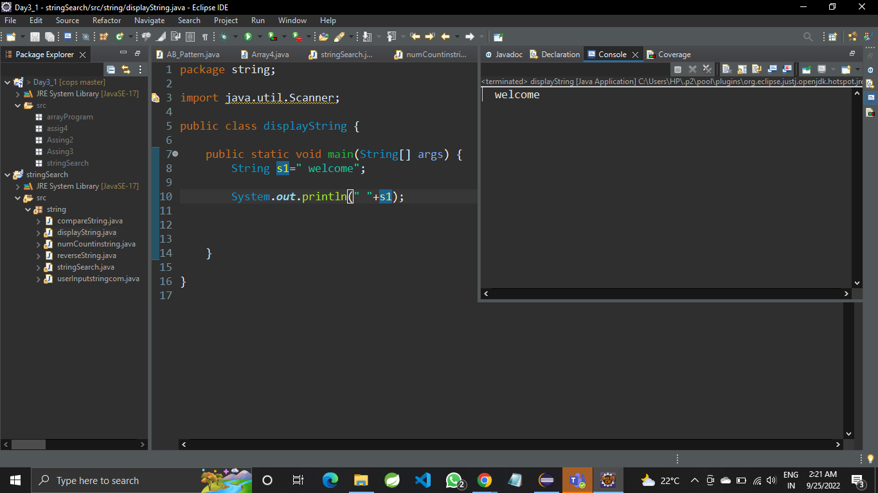  
  
  
  
🠶Q 2 wap to ask two string  
values from user and check if they are equal or not

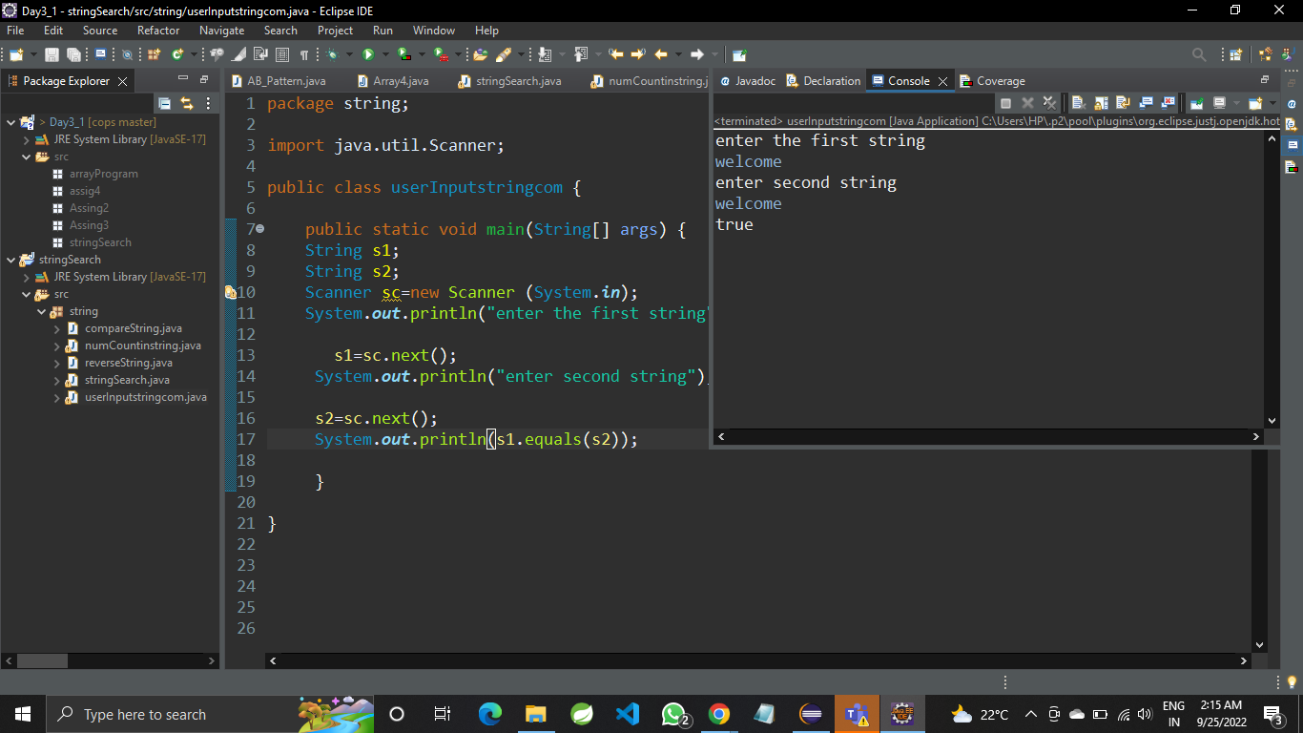  
  
  
strings 🠶Q 3 wap to compare two string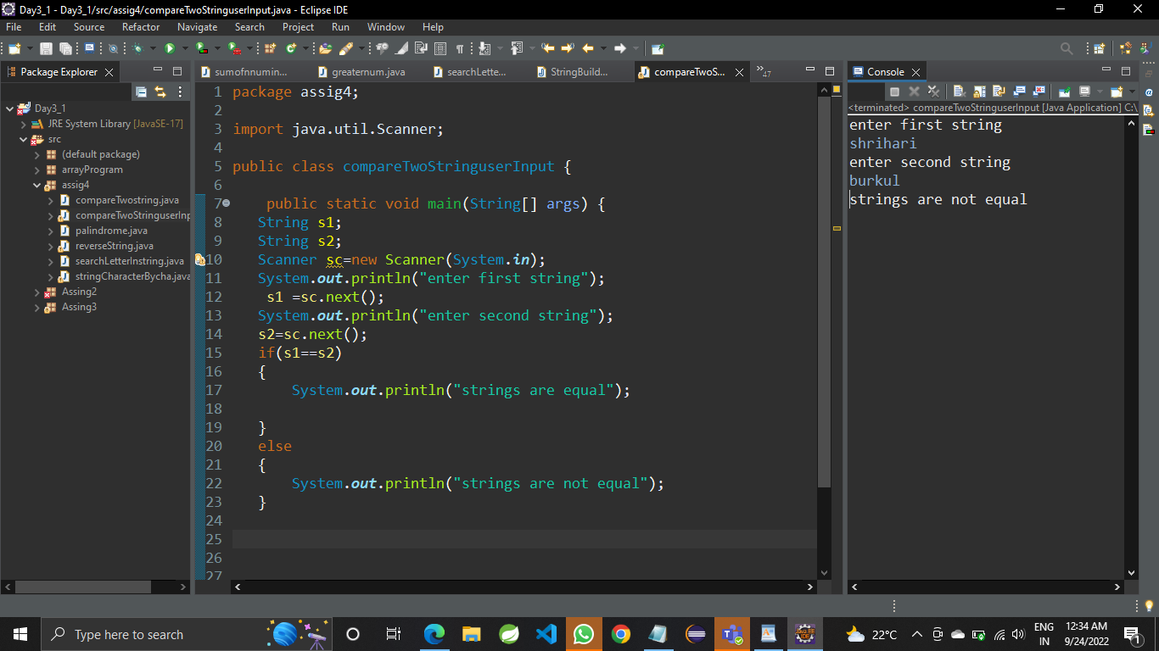  
  
  
  
🠶Q 4 wap to print string  
character by character  
  
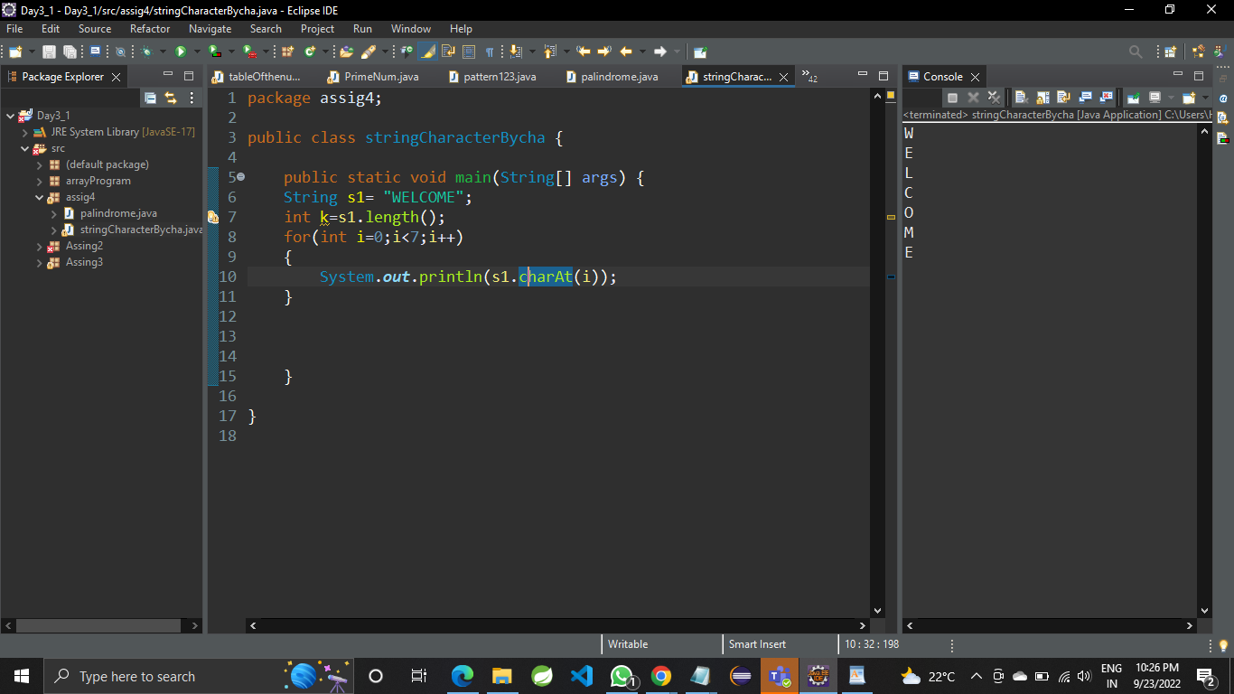  
 🠶Q 5 wap to check if string is  
palindrome or not   
  
  
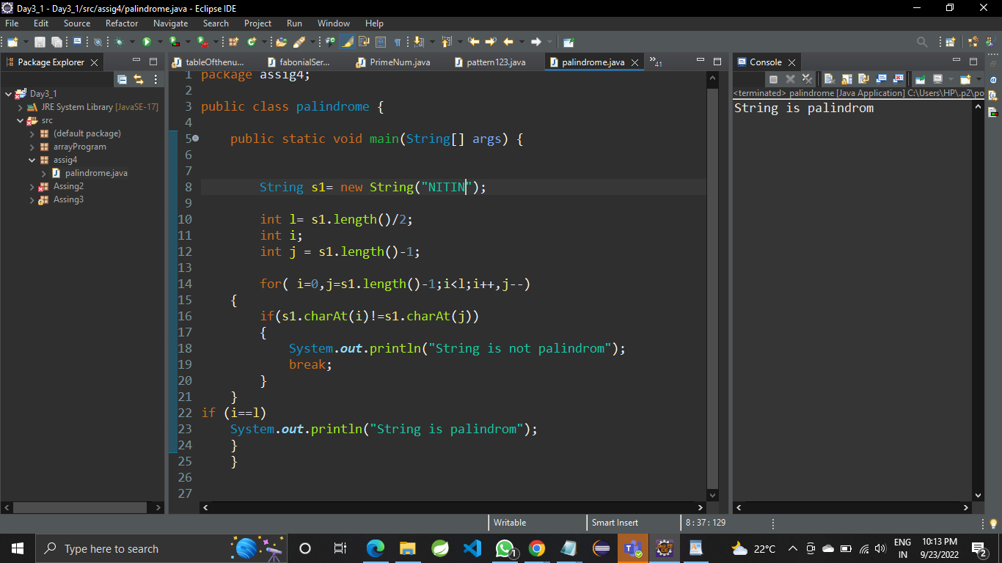

🠶Q 6 wap to count number of  
vowels and consonants in string 

🠶Q 7 wap to count number of  
words in given string

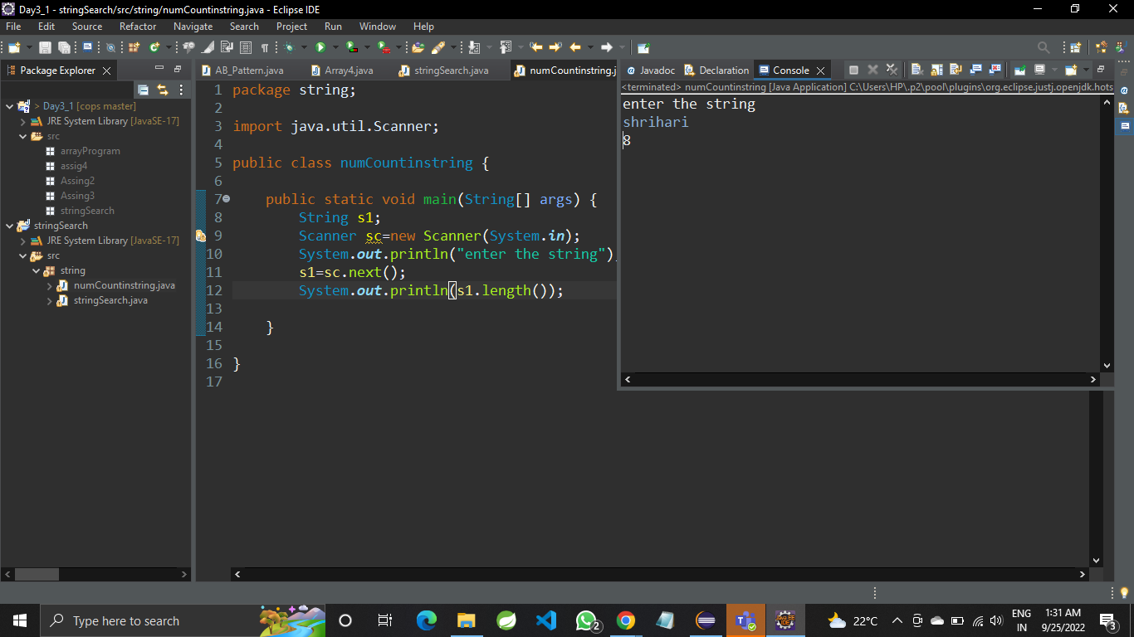

Q 8 wap to reverse word in given string

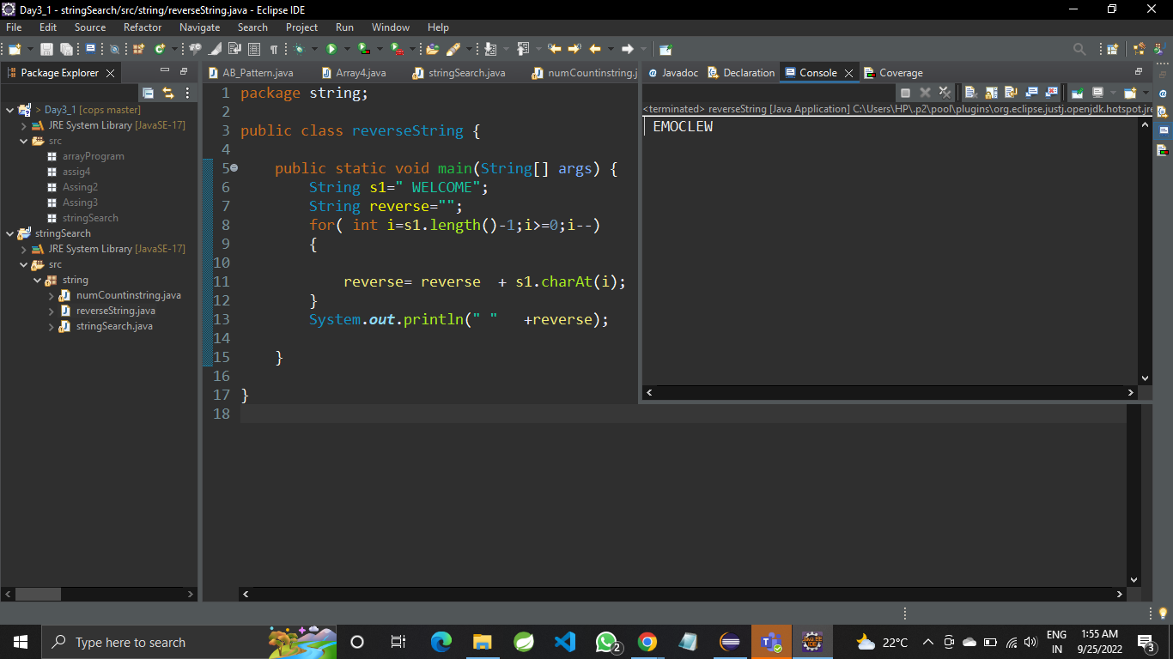

Q 9 wap to ask string from user and search for particular character in given string  .if found print " Found message " else print not found"

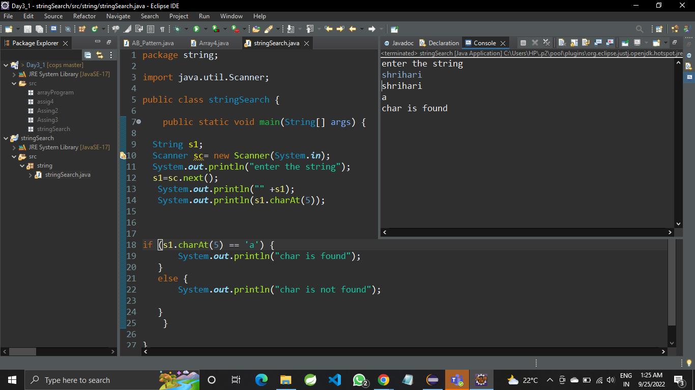

Add a class comment